The **Raspberry Pi** is a series of small single-board computers developed in the United Kingdom by the Raspberry Pi Foundation to promote teaching of basic [computer science](https://en.wikipedia.org/wiki/Computer_science) in schools and in developing countries. The original model became far more popular than anticipated, selling outside its target market for uses such as robotics. It does not include peripherals (such as keyboards and mice) and cases. However, some accessories have been included in several official and unofficial bundles.

The organization behind the Raspberry Pi consists of two arms. The first two models were developed by the Raspberry Pi Foundation. After the Pi Model B was released, the Foundation set up Raspberry Pi Trading, with Eben Upton as CEO, to develop the third model, the B+. Raspberry Pi Trading is responsible for developing the technology while the Foundation is an educational charity to promote the teaching of basic computer science in schools and in developing countries.

According to the Raspberry Pi Foundation, more than 5 million Raspberry Pi’s were sold by February 2015, making it the best-selling British computer. By November 2016 they had sold 11 million units, and 12.5 million by March 2017, making it the third best-selling "general purpose computer". In July 2017, sales reached nearly 15 million. In March 2018, sales reached 19 million.

Hardware

The Raspberry Pi hardware has evolved through several versions that feature variations in memory capacity and peripheral-device support.

[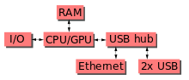](https://en.wikipedia.org/wiki/File:Raspberrypi_block_function_v01.svg)

This block diagram describes Model B and B+; Model A, A+, and the Pi Zero are similar, but lack the Ethernet and USB hub components. The Ethernet adapter is internally connected to an additional USB port. In Model A, A+, and the Pi Zero, the USB port is connected directly to the system on a chip (SoC). On the Pi 1 Model B+ and later models the USB/Ethernet chip contains a five-port USB hub, of which four ports are available, while the Pi 1 Model B only provides two. On the Pi Zero, the USB port is also connected directly to the SoC, but it uses a micro USB (OTG) port.

**Processor**

[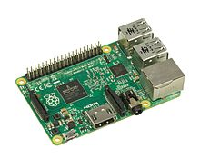](https://en.wikipedia.org/wiki/File:Raspberry-Pi-2-Bare-BR.jpg)

The Raspberry Pi 2B uses a 32-bit 900 MHz quad-core ARM Cortex-A7processor.

The Broadcom BCM2835 SoC used in the first generation Raspberry Pi[[20]](https://en.wikipedia.org/wiki/Raspberry_Pi" \l "cite_note-Broadcom-BCM2835-Website-20) includes a 700 MHz ARM11 76JZF-S processor, VideoCore IV graphics processing unit (GPU),[[21]](https://en.wikipedia.org/wiki/Raspberry_Pi#cite_note-grandmax_brose_2012-21) and RAM. It has a level 1 (L1) cache of 16 KB and a level 2 (L2) cache of 128 KB. The level 2 cache is used primarily by the GPU. The SoC is stacked underneath the RAM chip, so only its edge is visible. The 1176JZ(F)-S is the same CPU used in the original iPhone, although at a higher clock rate, and mated with a much faster GPU.

The earlier V1.1 model of the Raspberry Pi 2 used a Broadcom BCM2836 SoC with a 900 MHz 32-bit, [quad-core](https://en.wikipedia.org/wiki/Quad_Core) ARM Cortex-A7 processor, with 256 KB shared L2 cache.[[23]](https://en.wikipedia.org/wiki/Raspberry_Pi#cite_note-2-B-Announcement-23) The Raspberry Pi 2 V1.2 was upgraded to a Broadcom BCM2837 SoC with a 1.2 GHz 64-bit quad-core ARM Cortex-A53 processor,[[24]](https://en.wikipedia.org/wiki/Raspberry_Pi#cite_note-24) the same SoC which is used on the Raspberry Pi 3, but underclocked (by default) to the same 900 MHz CPU clock speed as the V1.1. The BCM2836 SoC is no longer in production as of late 2016.

The Raspberry Pi 3+ uses a Broadcom BCM2837B0 SoC with a 1.4 GHz 64-bit quad-core ARM Cortex-A53 processor, with 512 KB shared L2 cache.[[1]](https://en.wikipedia.org/wiki/Raspberry_Pi#cite_note-RapsberryPi3B+Release-1)

**Performance**

While operating at 700 MHz by default, the first generation Raspberry Pi provided a real-world performance roughly equivalent to 0.041 GFLOPS.[[25]](https://en.wikipedia.org/wiki/Raspberry_Pi#cite_note-eLinux-perf-25)[[26]](https://en.wikipedia.org/wiki/Raspberry_Pi#cite_note-hackaday-raspi-26) On the CPU level the performance is similar to a 300 MHz Pentium II of 1997–99. The GPU provides 1 Gpixel/s or 1.5 Gtexel/s of graphics processing or 24 GFLOPS of general purpose computing performance. The graphical capabilities of the Raspberry Pi are roughly equivalent to the performance of the [Xbox](https://en.wikipedia.org/wiki/Xbox_(console)) of 2001.

Raspberry Pi 2 V1.1 included a quad-core Cortex-A7 CPU running at 900 MHz and 1 GB RAM. It was described as 4–6 times more powerful than its predecessor. The GPU was identical to the original. In parallelized benchmarks, the Raspberry Pi 2 V1.1 could be up to 14 times faster than a Raspberry Pi 1 Model B+.

The Raspberry Pi 3, with a quad-core ARM Cortex-A53 processor, is described as having ten times the performance of a Raspberry Pi 1.[[28]](https://en.wikipedia.org/wiki/Raspberry_Pi#cite_note-:0-28) This was suggested to be highly dependent upon task threading and instruction set use. Benchmarks showed the Raspberry Pi 3 to be approximately 80% faster than the Raspberry Pi 2 in parallelized tasks.

**Overclocking**

Most Raspberry Pi systems-on-chip could be overclocked to 800 MHz, and some to 1000 MHz. There are reports the Raspberry Pi 2 can be similarly overclocked, in extreme cases, even to 1500 MHz (discarding all safety features and over-voltage limitations). In the Raspbian Linux distro the overclocking options on boot can be done by a software command running "sudo raspi-config" without voiding the warranty.[[30]](https://en.wikipedia.org/wiki/Raspberry_Pi#cite_note-Turbo_mode-30) In those cases the Pi automatically shuts the overclocking down if the chip temperature reaches 85 °C (185 °F), but it is possible to override automatic over-voltage and overclocking settings (voiding the warranty); an appropriately sized heat sink is needed to protect the chip from serious overheating.

Newer versions of the firmware contain the option to choose between five overclock ("turbo") presets that when used, attempt to maximize the performance of the SoC without impairing the lifetime of the board. This is done by monitoring the core temperature of the chip and the CPU load, and dynamically adjusting clock speeds and the core voltage. When the demand is low on the CPU or it is running too hot the performance is throttled, but if the CPU has much to do and the chip's temperature is acceptable, performance is temporarily increased with clock speeds of up to 1 GHz, depending on the individual board and on which of the turbo settings is used.

The seven overclock presets are:

* none; 700 MHz ARM, 250 MHz core, 400 MHz SDRAM, 0 overvolting
* modest; 800 MHz ARM, 250 MHz core, 400 MHz SDRAM, 0 overvolting,
* medium; 900 MHz ARM, 250 MHz core, 450 MHz SDRAM, 2 overvolting,
* high; 950 MHz ARM, 250 MHz core, 450 MHz SDRAM, 6 overvolting,
* turbo; 1000 MHz ARM, 500 MHz core, 600 MHz SDRAM, 6 overvolting,
* Pi 2; 1000 MHz ARM, 500 MHz core, 500 MHz SDRAM, 2 overvolting,
* Pi 3; 1100 MHz ARM, 550 MHz core, 500 MHz SDRAM, 6 overvolting. In system information the CPU speed will appear as 1200 MHz. When idling, speed lowers to 600 MHz.

In the highest (*turbo*) preset the SDRAM clock was originally 500 MHz, but this was later changed to 600 MHz because 500 MHz sometimes causes SD card corruption. Simultaneously in *high* mode the core clock speed was lowered from 450 to 250 MHz, and in *medium*mode from 333 to 250 MHz.

The Raspberry Pi Zero runs at 1 GHz.

The CPU on the first and second generation Raspberry Pi board did not require cooling, such as a heat sink or fan, even when overclocked, but the Raspberry Pi 3 may generate more heat when overclocked.

**RAM**

On the older beta Model B boards, 128 MB was allocated by default to the GPU, leaving 128 MB for the CPU. On the first 256 MB release Model B (and Model A), three different splits were possible. The default split was 192 MB (RAM for CPU), which should be sufficient for standalone 1080p video decoding, or for simple 3D, but probably not for both together. 224 MB was for Linux only, with only a 1080p framebuffer, and was likely to fail for any video or 3D. 128 MB was for heavy 3D, possibly also with video decoding (e.g. XBMC). Comparatively the Nokia 701 uses 128 MB for the Broadcom VideoCore IV.

For the later Model B with 512 MB RAM new standard memory split files (arm256\_start.elf, arm384\_start.elf, arm496\_start.elf) were initially released for 256 MB, 384 MB and 496 MB CPU RAM (and 256 MB, 128 MB and 16 MB video RAM) respectively. But a week or so later the RPF released a new version of start.elf that could read a new entry in config.txt (gpu\_mem=*xx*) and could dynamically assign an amount of RAM (from 16 to 256 MB in 8 MB steps) to the GPU, so the older method of memory splits became obsolete, and a single start.elf worked the same for 256 MB and 512 MB Raspberry Pi’s.

The Raspberry Pi 2 and the Raspberry Pi 3 have 1 GB of RAM. The Raspberry Pi Zero and Zero W have 512 MB of RAM.

**Networking**

The Model A, A+ and Pi Zero have no Ethernet circuitry and are commonly connected to a network using an external user-supplied USB Ethernet or Wi-Fi adapter. On the Model B and B+ the Ethernet port is provided by a built-in USB Ethernet adapter using the SMSC LAN9514 chip. The Raspberry Pi 3 and Pi Zero W (wireless) are equipped with 2.4 GHz WiFi 802.11n (150 Mbit/s) and Bluetooth 4.1 (24 Mbit/s) based on the Broadcom BCM43438 FullMAC chip with no official support for monitor mode but implemented through unofficial firmware patching[[40]](https://en.wikipedia.org/wiki/Raspberry_Pi#cite_note-40) and the Pi 3 also has a 10/100 Mbit/s Ethernet port. The Raspberry Pi 3B+ features dual-band IEEE 802.11b/g/n/ac WiFi, Bluetooth 4.2, and Gigabit Ethernet (limited to approximately 300 Mbit/s by the USB 2.0 bus between it and the SoC).

**Peripherals**

[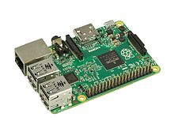](https://en.wikipedia.org/wiki/File:Raspberry-Pi-2-Bare-FL.jpg)

The Model 2B boards incorporate four USB ports for connecting peripherals.

The Raspberry Pi may be operated with any generic [USB computer keyboard](https://en.wikipedia.org/wiki/USB_computer_keyboard) and [mouse](https://en.wikipedia.org/wiki/Computer_mouse).[[41]](https://en.wikipedia.org/wiki/Raspberry_Pi#cite_note-VerifiedPeripheralList-41) It may also be used with USB storage, USB to MIDI converters, and *virtually* any other device/component with USB capabilities.

Other peripherals can be attached through the various pins and connectors on the surface of the Raspberry Pi.[[42]](https://en.wikipedia.org/wiki/Raspberry_Pi#cite_note-42)

**Video**

[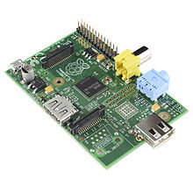](https://en.wikipedia.org/wiki/File:Raspberry_Pi_-_Model_A.jpg)

The early Raspberry Pi 1 Model A, with an HDMI port and a standard RCA composite video port for older displays

The video controller can generate standard modern TV resolutions, such as HD and Full HD, and higher or lower monitor resolutions as well as older NTSC or PAL standard CRT TV resolutions. As shipped (i.e., without custom overclocking) it can support the following resolutions: 640×350 EGA; 640×480 VGA; 800×600 SVGA; 1024×768 XGA; 1280×720 720p HDTV; 1280×768 WXGA variant; 1280×800 WXGA variant; 1280×1024 SXGA; 1366×768 WXGA variant; 1400×1050 SXGA+; 1600×1200 UXGA; 1680×1050 WXGA+; 1920×1080 1080p HDTV; 1920×1200 WUXGA.

Higher resolutions, up to 2048×1152, may work or even 3840×2160 at 15 Hz (too low a frame rate for convincing video). Note also that allowing the highest resolutions does not imply that the GPU can decode video formats at these resolutions; in fact, the Pi’s are known to not work reliably for H.265 (at those high resolutions), commonly used for very high resolutions (however, most common formats up to Full HD do work).

Although the Raspberry Pi 3 does not have H.265 decoding hardware, the CPU is more powerful than its predecessors, potentially fast enough to allow the decoding of H.265-encoded videos in software.[[47]](https://en.wikipedia.org/wiki/Raspberry_Pi#cite_note-47) The GPU in the Raspberry Pi 3 runs at higher clock frequencies of 300 MHz or 400 MHz, compared to previous versions which ran at 250 MHz.[[48]](https://en.wikipedia.org/wiki/Raspberry_Pi" \l "cite_note-48)

The Raspberry Pi’s can also generate 576i and 480i composite video signals, as used on old-style (CRT) TV screens and less-expensive monitors through standard connectors – either RCA or 3.5 mm phono connector depending on models. The television signal standards supported are PAL-BGHID, PAL-M, PAL-N, NTSC and NTSC-J.

**Real-time clock**

None of the current Raspberry Pi models have a built-in real-time clock, so they are unable to keep track of the time of day independently. As a workaround, a program running on the Pi can retrieve the time from a network time server or from user input at boot time, thus knowing the time while powered on. To provide consistency of time for the file system, the Pi automatically saves the current system time on shutdown, and re-loads that time at boot.

A real-time hardware clock with battery backup, such as the DS1307, may be added (often via the I²C interface).

**Connectors**

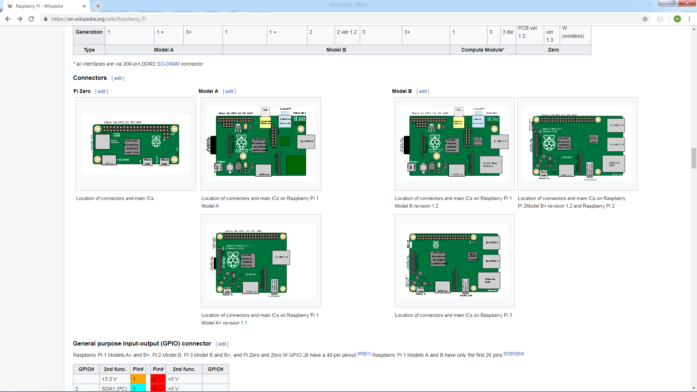

### General purpose input-output (GPIO) connector[[edit](https://en.wikipedia.org/w/index.php?title=Raspberry_Pi&action=edit&section=16)]

Raspberry Pi 1 Models A+ and B+, Pi 2 Model B, Pi 3 Model B and B+, and Pi Zero and Zero W GPIO J8 have a 40-pin pinout.  Raspberry Pi 1 Models A and B have only the first 26 pins.

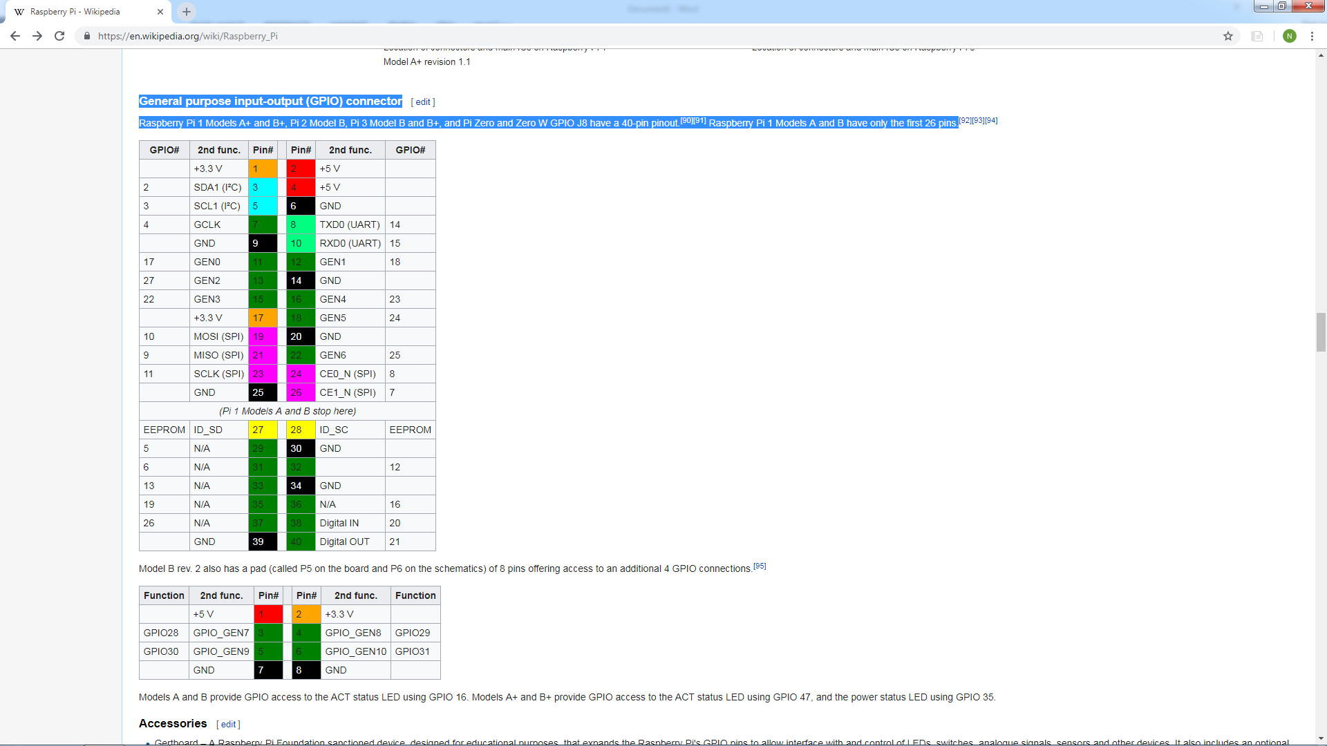

**Operating Systems**

Various operating systems for the Raspberry Pi can be installed on a MicroSD, MiniSD or SD card, depending on the board and available adapters; seen here is the MicroSD slot located on the bottom of a Raspberry Pi 2 board.

The Raspberry Pi Foundation provides Raspbian, a Debian-based Linux distribution for download, as well as third-party Ubuntu, Windows 10 IoT Core, RISC OS, and specialized media center distributions. It promotes Python and Scratch as the main programming languages, with support for many other languages. The default firmware is closed source, while an unofficial open source is available. Many other operating systems can also run on the Raspberry Pi, including the formally verified microkernel, seL4. Other third-party operating systems available via the official website include Ubuntu MATE, Windows 10 IoT Core, RISC OS and specialized distributions for the [Kodi](https://en.wikipedia.org/wiki/Kodi_(software)" \o "Kodi (software)) media center and classroom management.